**EXPERIMENT 2**

**Title:** Designing a Logo using GIMP

**Objective:** To design a simple logo using GIMP.

**Theory:**

**GIMP** stands for GNU Image Manipulation Program. It is a cross-platform image editor available for GNU/Linux, OS X, Windows and more operating systems. It is [free software](https://www.gnu.org/philosophy/free-sw.html), and its [source code](https://git.gnome.org/browse/gimp) can be changed and [distribute](https://www.gnu.org/licenses/quick-guide-gplv3.en.html)d. Whether one is a graphic designer, photographer, illustrator, or scientist, GIMP provides with sophisticated tools to get the job done. We can further enhance our productivity with this platform. GIMP is a high-quality framework for scripted image manipulation, with multi-language support such as C, C++, Perl, Python, Scheme and more! It can be downloaded directly from www.gimp.org

**Procedure:**

**Step 1:** Open GIMP. Go to File > Open as Layers… Now, browse the picture/drawing and open it as a layer.

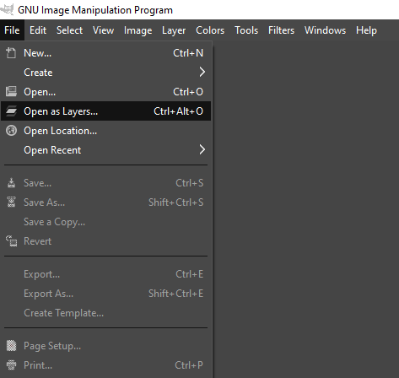

**Step 2:** Now, choose Free Select Tool from Toolbar, and start selecting the border/boundaries of the picture.

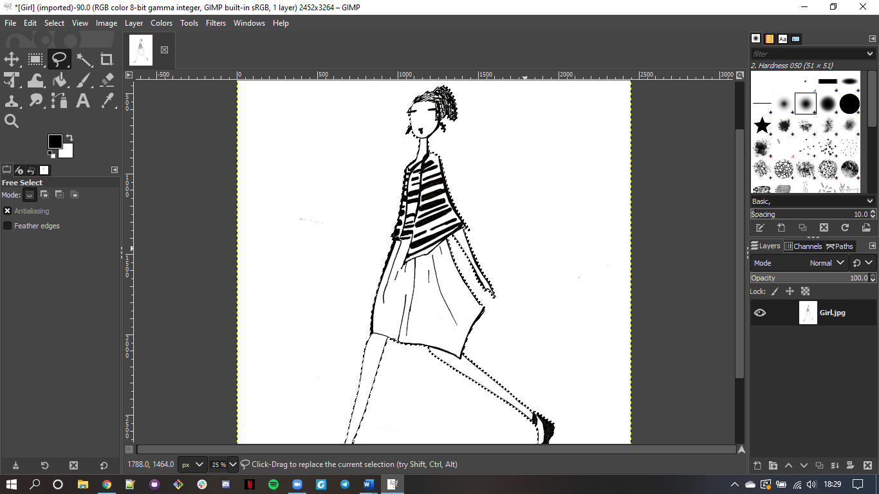

**Step 3:** After selecting all the boundaries, connect the last point with the first one and cut that portion from that image using Ctrl+X.

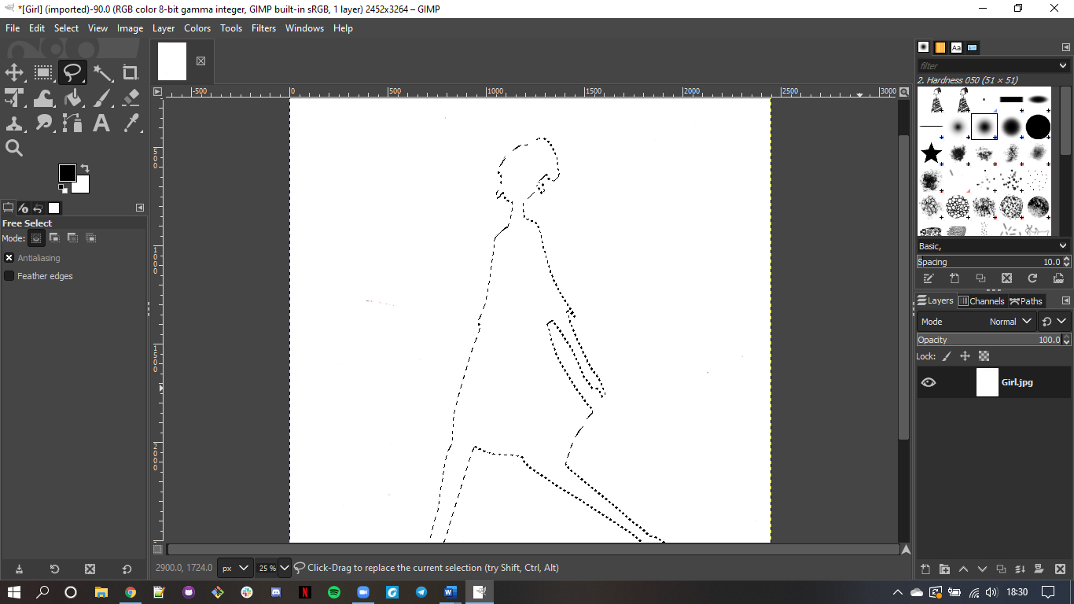

**Step 4:** Paste this image on the white background layer from the Layers column.

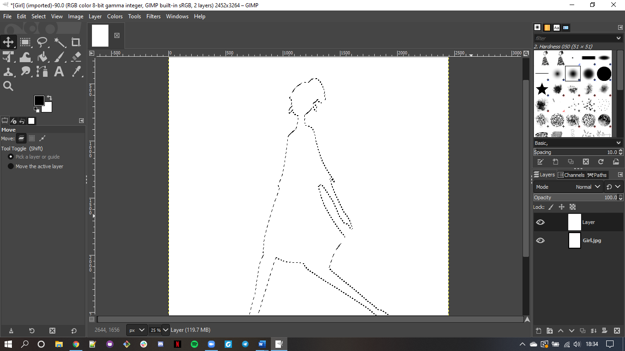

**Step 5:** Select Paintbrush tool from the toolbar and a colour from colour palette.

**Step 6:** Start drawing the boundaries of the letter with steady hand, so that you could get a layer like this.

**Step 7:** Now select the Bucket Fill tool from toolbar and modify its setting according to your creativity.

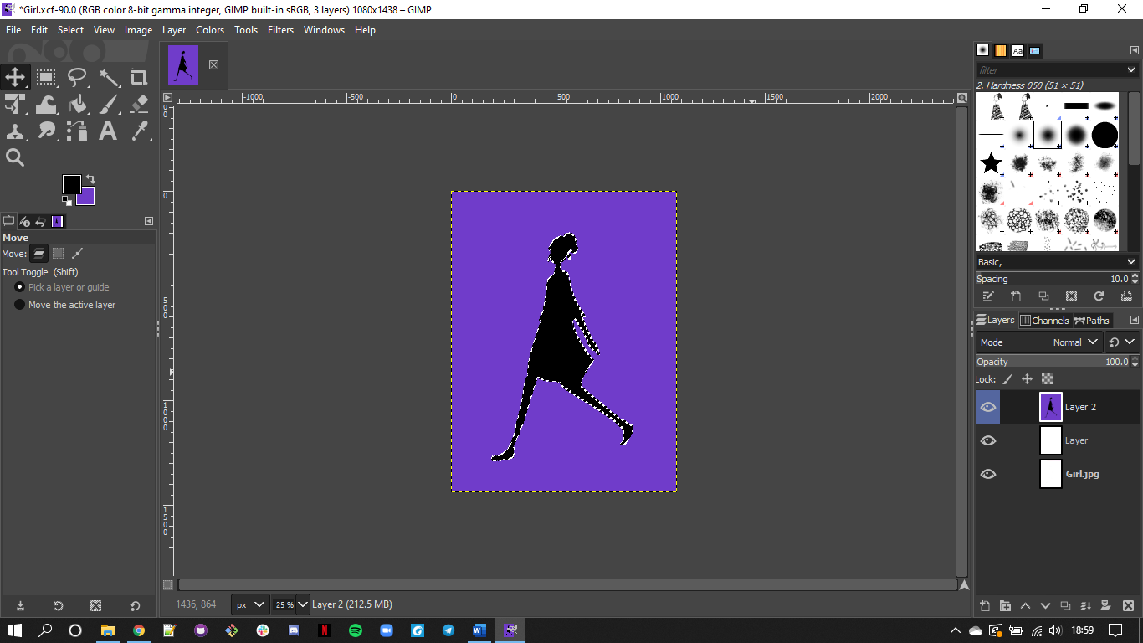

**Step 8:** Repeat Step 2 and add another image.

**Step 9:** To add text to your image, select Text Tool from toolbar.

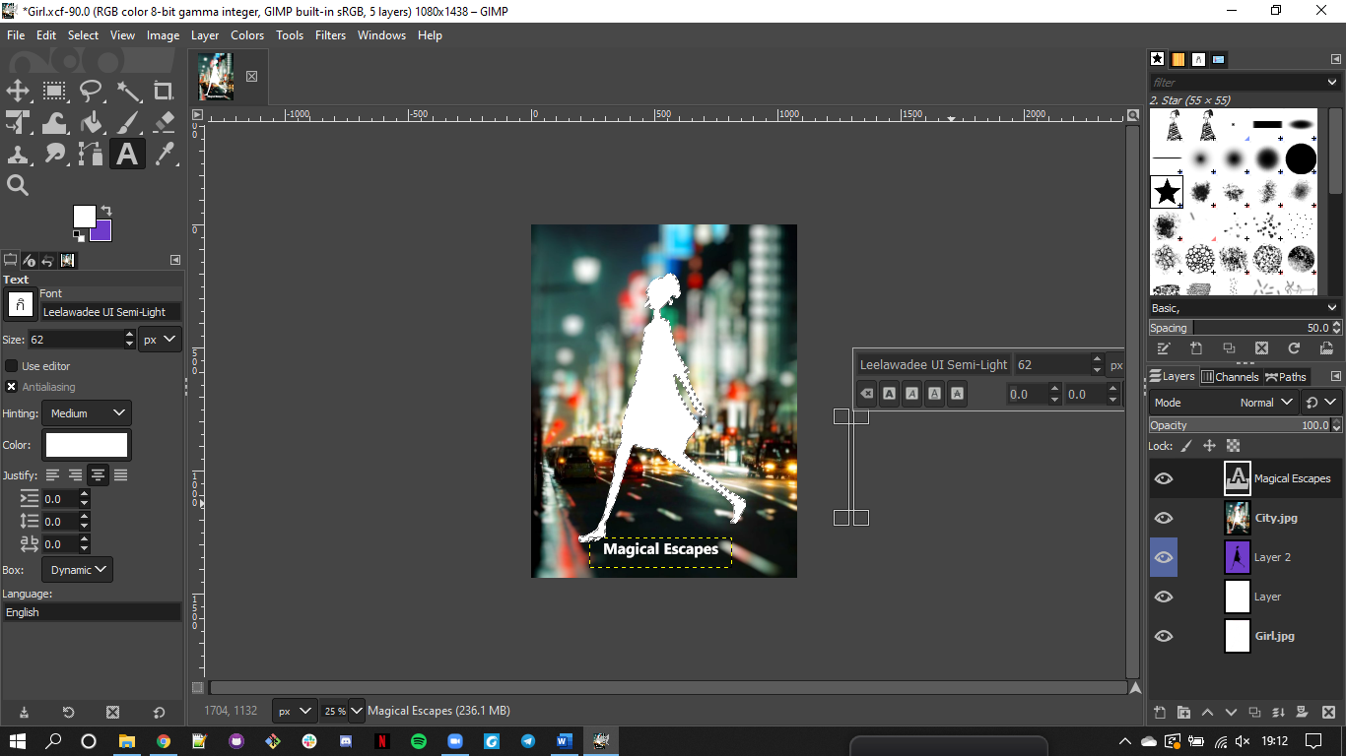

**Step 10:** Save the output and export it as png.

**Conclusion:** We have successfully created a logo of our choice using GIMP.